INSTRUCTIONS: COLLECTION OF SAMPLES FOR DETECTING INTESTINAL PARASITES

Testing for the presence of intestinal parasites necessitates sending faecal samples and perianal smears (smears taken from the area of the rectum) for laboratory examination.

- Faecal samples of hazelnut size are collected three times daily on alternate days.
- Smears from the area of the rectum are taken with adhesive tape attached to a slide in the following manner:

The tape is separated from the slide to two thirds of its length and the adhesive side is pressed against the anal opening, across the crease between the buttocks. The buttocks are drawn apart prior to application of the tape and squeezed together for thirty seconds following application. The tape is then reattached to the slide.

Patients are not to wash the anus for two days prior to the smear.

Samples are collected 3x daily on alternate days.

Collected material must be labelled and stored at 4ºC in a refrigerator. Both samples are sent to the laboratory together.

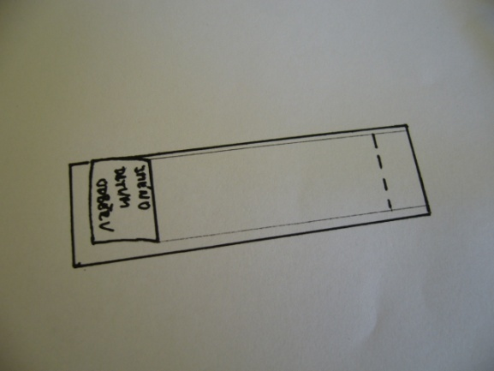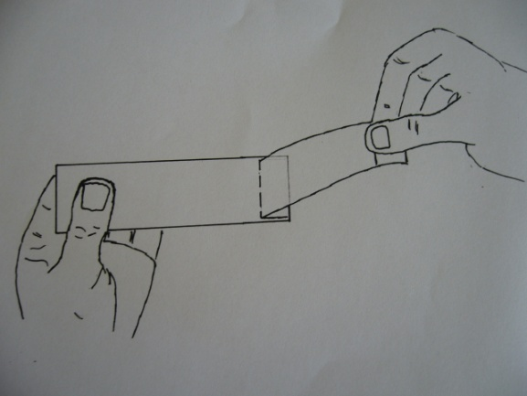
- Cellulose-tape slide preparation.
1.
2. The tape is separated from the slide to two thirds of its lenght.
2.

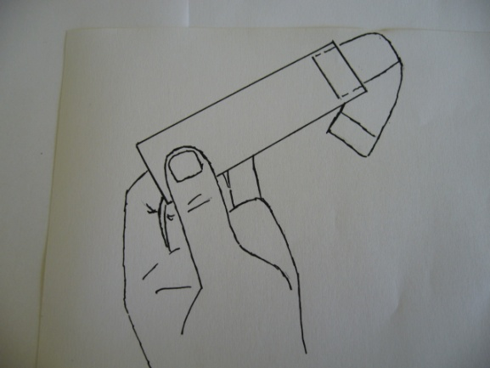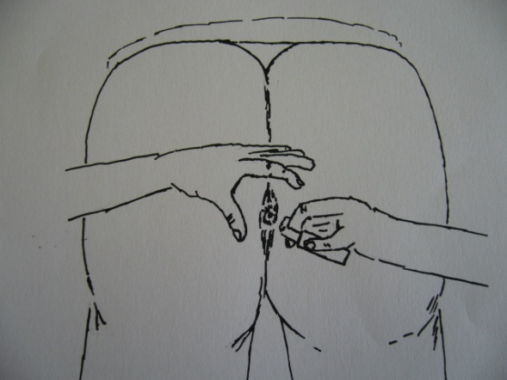
3. Loop tape over end of slide.
3.
4. The adhesive side is pressed againts the anal opening, across the crease between the buttocks. The buttocks are drawn apart prior to application of the tape and squeezed together for thirty seconds following application.
4.

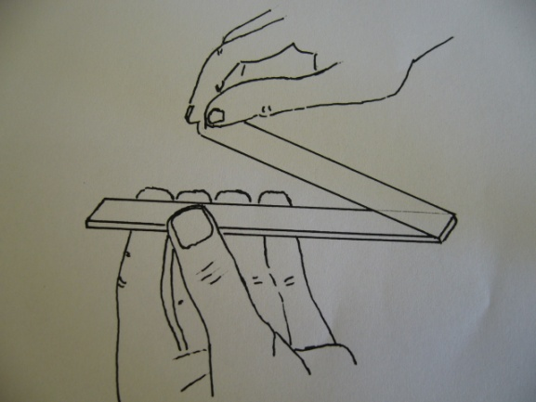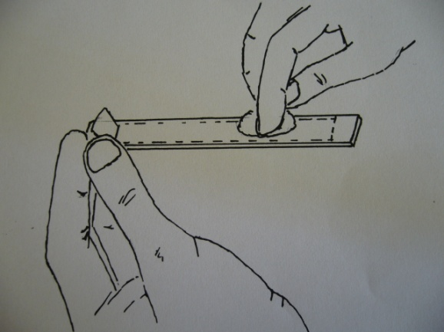
5. The tape is then reattached to the slide.
5.
6. Smooth tape with cotton or gauze.
6.
Note: Specimens are best obtained the first thing in the morning before the person has a bowel movement or bath.

